
Moose Habitat Selection and Movement Dynamics in a Changing Thermal Landscape under Climate Change
Accounting for circadian rhythmicity using harmonic terms

Niels van der Vegt
Independent project • 36 credits
Swedish University of Agricultural Sciences, SLU
Department of Wildlife, Fish, and Environmental Studies

Moose Habitat Selection and Movement Dynamics in a Changing Thermal Landscape under Climate Change - Accounting for circadian rhythms using harmonic terms

Niels van der Vegt

Supervisor: | Wiebke Neumann, Swedish University of Agricultural Sciences, Department of Wildlife, Fish, and Environmental Studies
Assistant supervisor: | Sytze de Bruin, Wageningen Universty, Department of Geo-information Sciences
Examiner: | Tim Hofmeester, Swedish University of Agricultural Sciences, Department of Wildlife, Fish, and Environmental Studies

Credits: | 36
Level: | A2E
Course title: | Master’s thesis in Biology – Wildlife, Fish, and Environental Studies
Course code: | EX0971
Programme/education:
Course coordinating dept:
Place of publication: | Umeå, Västerbotten, Sweden
Year of publication: | -
Cover picture: | -
Copyright: | -
Keywords: | -

Swedish University of Agricultural Sciences
Faculty of Forest Sciences
Department of Wildlife, Fish, and Environmental Studies
Unit/section (add if needed or delete row)

Abstract

Keywords: keyword 1, keyword 2… (use the same keywords as on the previous page)

Table of contents
List of tables 6
List of figures 7
Abbreviations 8
1. This is the style “Heading 1” Error! Bookmark not defined.
1.1 This is the style “Heading 2” Error! Bookmark not defined.
1.1.1 This is the style “Heading 3” Error! Bookmark not defined.
1.2 This is a table with a table description Error! Bookmark not defined.
1.3 This is a figure with a figure description Error! Bookmark not defined.
1.4 This is a block quotation Error! Bookmark not defined.
1.5 You can use “Text using space” instead of “Normal”, remember to be consistent throughout the text Error! Bookmark not defined.
References 11
Popular science summary 24
Appendix 1 25

List of tables
Adding a list of tables
To include a list of tables successfully the table descriptions need to be added correctly. The list of tables is then generated automatically. Read more: https://slu-se.instructure.com/courses/1097/pages/tables.
Please remove this box when you no longer need these instructions.
Example of a list of tables:

Table 1. Very important data shown in a table. Error! Bookmark not defined.

List of figures
Adding a list of figures
To include a list of figures successfully the figure descriptions need to be added correctly. The list of figures is then generated automatically. Read more: https://slu-se.instructure.com/courses/1097/pages/figures.
Please remove this box when you no longer need these instructions.
Example of a list of figures:

Figure 1. Cows grazing in an open field. (Uzzaman, A. (2009). Cool as a cow.[photography]. https://flic.kr/p/5XxKEa [2024-09-02] CC BY-NC 2.0) Error! Bookmark not defined.

Abbreviations
Adding a list of abbreviations
To make it easier for the reader, you can make a list with common abbreviations in alphabetical order. On this page there is a table you can use to make your list. Tips: Activate the display of Show/Hide formats in order to see blank spaces, page breaks etc:

Please remove this box when you no longer need these instructions.

Abbreviation | Description
SLU | Swedish University of Agricultural Sciences
SLU | Swedish University of Agricultural Sciences
SLU | Swedish University of Agricultural Sciences

Introduction
Climate change is projected to disrupt climactic stability and escalate the frequency and intensity of extreme weather events such as heatwaves, freeze-thaw cycles, droughts, floods, and storms (Mellander et al. 2007; Medicine et al. 2016). This unsettling trajectory bestows new challenges on animals that are well adapted to specific environmental niches, having already resulted in range shifts, diminished fitness, or even extinction of species (Parmesan & Yohe 2003; Thomas et al. 2004; Zimova et al. 2016). The European moose (Alces alces) is an example of a species that has evolved to the cold and stable climatic environments prevalent in the boreal and (sub) arctic regions of the world. Nowadays, the northern ungulate is increasingly confronted with the external conditions of a less temperate climate. Weather fluctuations can directly and indirectly influence moose fitness. An example of a direct impact is dry, hot springs causing reduced fecundity and calf body mass in Swedish moose (Holmes et al. 2021). Indirect repercussions can manifest as reduced access to foraging habitat due to ground-icing after a freeze-thaw cycle, or habitat destruction after a major storm (Abernathy et al. 2019). Fortunately, animals possess remarkable capacity to adapt to shifting environments, and can often do so by migrating, seeking alternative habitats, or adjusting behaviour — a phenomenon termed phenotypic plasticity. Over the past decades, findings in moose studies show moose selectin for thermal shelter over foraging quality (van Beest et al. 2012), and individuals displaying thermoregulatory behaviours amidst heat stress exhibiting improved body conditions (van Beest & Milner 2013). Questions are now raised on the effects of these findings, an whether species can adapt fast enough to keep up with their changing environments (Visser 2008).

Changes in behavioural patterns, even when beneficial for individual fitness, may inadvertently side line other vital activities such as foraging or parental care (Cunningham et al. 2021). With improvements in technology and new statistical techniques applied. Most studies have focused on captive moose, or moose in the temperate range, lots of studies do not take into account the temporal dimension, or limit their analysis to the maximum daily temperature. Here we attempt to investigate daily circadian rhythm as moose experience different temperature ranges.

This study aims to provide insights into how extreme temperatures influence the circadian rhythm of Swedish moose by looking at movement and habitat selection. We’ll attempt to reproduce earlier findings by van Beest, …. We’ll expand on earlier work by incorporating a temporal dimension into our analysis and investigating whether changes in circadian rhythm occur. We’ll look at differences between boreal and temperate populations.

We’ll consider the following hypotheses:

- Moose show decreased movement during heatwave events.

- During heatwaves, moose are expected to show a preference for forests over clear areas, aiding in their thermoregulation efforts.

- During heatwaves, moose are expected to show a preference for wetlands and proximity to water sources, aiding in their thermoregulation efforts.

- In alpine regions, selection for elevation occurs during heatwaves.

- During heatwaves, moose are anticipated to adjust their activity patterns, reducing time spend in optimal foraging habitat and increasing time spend foraging during twilight and nighttime hours.

Theoretical Framework

Step Selection Functions (SSF)
With the increasing availability of telemetry data, new approaches have emerged to model habitat selection and movement decisions. Step selection functions (SSFs) provide a framework for understanding fine-scale movement choices of individual animals by analyzing them on a step-by-step basis (Thurfjell et al. 2014). A step here, is defined as the straight-line segment between two consecutive recorded locations of an individual, representing a movement decision. SSFs compare observed steps to alternative steps the animal could have taken, but did not (Mawer et al. 2023). Each observed step is paired with a set of alternative steps drawn from an empirical movement distribution fitted to the animal’s movement patterns. Commonly used distributions are a (zero-inflated) Gamma distribution for step length, and a von Mises distribution for turning angle (Signer et al. 2019; Fieberg et al. 2021). The probability of selecting a particular step is estimated based on covariates associated with each step. To model habitat preferences and accessibility, environmental covariates such as vegetation type or elevation can be included. Similarly step length, log-transformed step length, and turning angle can be included to account for an animal’s movement tendencies. Finally interactions of environmental and movement covariates can be included at the start of the step to model how directly and quickly an animal can move through the landscape (Signer et al. 2019).

The general form of an SSF resembles a resource selection function (RSF) and is expressed in exponential form as (Eq. 1):

$$\begin{aligned}ω\left(x\right)=\exp\left(β_{1}x_{1}+β_{2}x_{2}+…+β_{n}x_{n}\right)\#(1\end{aligned})$$

Where $ω$ = represents the relative probability of selecting a step with covariates $x_{1} to x_{n}$. Coefficients $β$are estimated by using conditional logistic regression, maximizing the likelihood of the selected steps relative to steps that were available (Thurfjell et al. 2014; Fieberg et al. 2021). After fitting, the slope coefficients $exp\left(β_{i}\right)$ can be interpreted as the relative strength of selection, and represent the relationship between the likelihood of being selected and the covariate value. A positive $β$suggests affinity, while a negative $β$ indicates avoidance for a particular covariate.

Accounting for Circadian Rythms using Harmonic Terms
Recent studies on SSFs have increasingly emphasized the importance of incorporating behavioral states as explanatory variables for movement decisions (Beumer et al. 2023; Chatterjee et al. 2024; Klappstein et al. 2024). An animal’s behavioral state strongly influences its needs and movement characteristics during a step. Accounting for behavior can be done by including behavioral state as an interaction term with environmental and movement covariates and by fitting movement distributions to movement data associated with each behavioral state (Beumer et al. 2023).

Predicting an animal’s behavior based on movement metrics is commonly done using state-predicting models such as Hidden Markov Models (HMMs). HMMs classify each movement step into discrete states (e.g., foraging vs. resting), generally based on movement metrics, through clustering techniques (McClintock & Michelot 2018; Glennie et al. 2023). However, this approach has limitations depending on the temporal resolution of the data. At large enough time intervals, animals may switch between behavioral states multiple times between successive GPS fixes. In such cases, HMMs can only provide a coarse approximation of true behavioral dynamics, potentially oversimplifying behaviour during the interval or failing to capture a behavioural shift accurately (Langrock et al. 2012; Glennie et al. 2023). An alternative approach that avoids this, is to use time-of-day categories, such as day, night, crepuscule, or other zeitgebers that cue circadian behaviour (van Beest et al. 2012). However, in high-latitude environments, such as our moose localizations within the Arctic Circle, the absence of night and crepuscular periods during the summer polar sun renders traditional time-of-day categorizations ineffective.

A more flexible approach compared to discrete behaviour or time-of-day categories would be through incorporating cyclical terms to represent changes over a diel. If we consider that selection for a covariate will most likely have some periodic function associated with an animal’s circadian rhythm, we can model this as a Fourier series of trigonometric functions. This transforms the original logistic regression, which predicts step probability based on covariates, into a dynamic harmonic regression that incorporates variability during a day. We recall the method from (Forrest et al. 2025), extending the SSF by incorporating harmonic terms as interaction effects with our main covariates (Eq. 2.1):

$$\begin{aligned}ω\left(x,β\left(τ;α\right)\right)=\exp\left(β_{1}\left(τ;α_{1}\right)x_{1}+⋯+β_{n}\left(τ;α_{n}\right)x_{n}\right)\#(2.1)\end{aligned}$$

In this model, $τ$ is the time at which the step occurs. The vector $α_{i}=(α_{i,0},…,α_{i,2P}$) contains the coefficients for the trigonometric functions that control how the covariate $x_{i}$ changes over time. Coefficients are defined for $p$ pairs of harmonics and $β_{i}\left(τ;α_{i}\right)$ is given as (Eq. 2.2):

$$\begin{aligned}β_{i}\left(τ;α_{i}\right)=α_{i,0}+\sum_{j=1}^{P}{α_{i,j}}\sin\left(\frac{2jπτ}{T}\right)+\sum_{j=1}^{P}{α_{i,j+P}}\cos\left(\frac{2jπτ}{T}\right) \#(2.2)\end{aligned}$$

Here, $α_{i,0}$ is the main effect of the covariate, which can be considered the affinity or aversion for a covariate irrespective of circadian rhythm. $T$ represents the period associated with the seasonality, which is a diel in our case. Increasing the number of harmonic pairs allows for finer temporal fluctuations of covariates, but caution is needed to avoid overfitting (Forrest et al. 2025). Alternatively, periodic functions can be modeled using spline functions, as recently shown in (Klappstein et al. 2024). However, this approach requires significantly more computational power and was not explored further in this study.

Population inference using Step Selection Functions
When estimating population-level effects from individual tracked animals, it is important to account for behavioral differences among individuals and within-individual correlation in habitat use (Fieberg et al. 2010; Chatterjee et al. 2024). Ignoring these factors violates the assumption of independence, leading to overfitted models and underestimated uncertainty (Fieberg et al. 2010; Muff et al. 2020).

One approach to address this issue is fitting a random-effects model with random slopes, where each individual receives unique slopes for relevant explanatory variables (Klappstein et al. 2024). However, this method is computationally demanding, and the number of parameters increases substantially when incorporating harmonics, due to the many possible combinations of individual-level random slopes and harmonic terms. A simpler alternative is the two-stage conditional logistic regression approach (Fieberg et al. 2010). This method first fits a SSF separately for each individual, and then averages the resulting coefficients to infer population-level responses. This approach is effective when sufficient data have been collected to estimate individual regression parameters, and when individuals can be considered independent (Fieberg et al. 2010; Muff et al. 2020). To summarize population effects, the mean value of the individual coefficients for an explanatory variable can be used. However when estimating variance, this method overestimates as it does not account for the inherit sampling uncertainty in the coefficient estimates of each animal (Fieberg et al. 2010). This uncertainty can be accounted for by weighting of each individual’s estimate according to its sampling variance. In practice this can be achieved by estimating the mean using an intercept-only linear regression model with inverse-variance weighting (Eq. 3).

$$\begin{aligned}\hat{β_{\text{population}}}=\frac{\sum_{i=1}^{n}{\frac{β_{i}}{\text{Var}\left(β_{i}\right)}}}{\sum_{i=1}^{n}{\frac{1}{\text{Var}\left(β_{i}\right)}}} \#\left(3\right)\end{aligned}$$

Finally, in the two-stage conditional logistic regression approach, it is important that each categorical variable is visited by each animal at least once (Fieberg et al. 2010; Muff et al. 2020). For instance, each habitat category being investigated should be represented in the data for every individual animal. If this condition is not met, the individual SSF will fail to estimate the selection for the missing category. While random effects models can handle missing categories, concerns should be raised about the interpretability of such estimates, as well as the reliability of the resulting variances.

Interpolating temperature using Space-Time Regression Kriging

Obtaining temperature at an animal’s step location has been approached through multiple methods. The most direct method involves using readings from a temperature sensor attached to the animal’s collar, provided this data is available. The key advantage of this approach is that there is no spatial or temporal discrepancy between the recorded temperature and the step location. On average, collar temperature measurements track ambient temperature trends but tend to exhibit consistently higher values (Ericsson et al. 2015; Messeri et al. 2019). Despite this general consistency, outliers are common due to factors such as body heat, sensor irradiation, placement, and air circulation. These factors can lead to overestimations of ambient temperature, sometimes exceeding the daily maximum temperature range (Messeri et al. 2019). An alternative approach is to use temperature data from the nearest weather station. This avoids sensor-related artifacts but introduces spatial and temporal mismatches. Weather stations are distributed unevenly across the landscape, and their reporting frequencies vary. Consequently, the spatial and temporal distances between an animal’s step and the nearest available temperature measurement differ between observations, introducing variability in explanatory data. These discrepancies can be mitigated by employing interpolation techniques that integrate both spatial and temporal dimensions to estimate temperature conditions at the precise locations and times of animal movements.

Kriging is a geostatistical interpolation method that provides an estimate of an unknown value at a given location by leveraging spatial autocorrelation in the data (Cressie & Wikle 2011). The fundamental idea is that nearby observations tend to be more similar than distant ones, and this relationship can be modeled using a covariance function. In its simplest form, ordinary kriging estimates an unknown value $\hat{Z}\left(s_{0}\right)$at location $s_{0}$ as a weighted sum of observed values from neighboring locations $s_{i} (Eq. 3.1)$​:

$$\begin{aligned}\hat{Z}\left(s_{0}\right) = \sum_{i=1}^{n}{λ_{i}} Z\left(s_{i}\right)\#\left(3.1\right)\end{aligned}$$

where $λ_{i}$are kriging weights that determine the contribution of each neighboring observation to the estimate. These weights are derived by solving a system of equations that minimizes estimation variance (Cressie & Wikle 2011). The spatial covariance structure is modeled using a semi-variogram $γ(h)$, which defines how similarity between observations decreases with increasing distance $h$. The variogram allows kriging to account for spatial autocorrelation by assigning higher weights to closer observations.

While ordinary kriging relies solely on spatial autocorrelation, interpolation can be improved by incorporating known environmental predictors through regression kriging. This approach first models the variable of interest, such as temperature, as a function of explanatory covariates (e.g., elevation, land cover, or latitude). By attempting to factor out all explanatory factors, we aim to isolate a purely spatial error, which can then be modeled and subsequently addressed using kriging on the residuals (Hengl et al. 2007). The predicted value takes the form of Eq 3.3, taken from (Hengl et al. 2007):

$$\begin{aligned}\hat{Z}\left(s_{0}\right) = \hat{m}\left(s_{0}\right)+\hat{e}\left(s_{0}\right) = \sum_{k=0}^{p}{\hat{β_{k}}}⋅q_{k}\left(s_{0}\right)+\sum_{i=1}^{n}{λ_{i}}⋅e\left(s_{i}\right)\#\left(3.3\right)\end{aligned}$$

where $\hat{m}\left(s_{0}\right)$ is the trend component of temperature, predicted through regression, $\hat{e}\left(s_{0}\right)$is the residual component, predicted through kriging. In the regression model, explanatory variables at location $s_{0}$ are represented by $q_{k}\left(s_{0}\right)$ with coefficient $β_{k}$. We can further expand this by considering the temporal dimension in our esimates, performing space-time kriging by deriving the kriging system in three dimensions (Eq 3.4).

$$\begin{aligned}\hat{Z}\left(s_{0},t_{0}\right)=\sum_{i=1}^{n}{λ_{i}Z\left(s_{i},t_{i}\right)}\#\left(3.4\right)\end{aligned}$$

An in-depth introduction to space-time kriging is out of scope for this study, but we refer the reader to (Montero et al. 2015) for an in-depth look into to the topic.

Material and Methods

Moose Localisations and Strata

Data Pre-processing
Moose location data were obtained from the Wireless Remote Animal Monitoring (WRAM) database, which compiles telemetry data from individual studies conducted since 2003 (Dettki et al. 2013). GPS collars fitted to moose recorded locations at three-hour intervals. The study was restricted to female moose to avoid the irregular movements and behaviors associated with the rutting season in males, and because the majority of available data originated from females. Data from all available years were included but limited to the summer season, defined as June through August, to exclude the migratory periods typical of moose in northern Sweden (van Moorter et al. 2021). To ensure a representative temporal sample of seasonal temperature, only tracking segments where moose were monitored for at least 70% of the summer season were included. This threshold was calculated by determining the theoretical maximum number of possible fixes within the June–August period (based on three-hour intervals) and dividing the number of actual recorded fixes by this value. Duplicate localizations and those recorded outside the borders of Sweden were removed. To account for ecological differences and regional variation in moose behavior, the study area was divided into strata based on limnic ecosystem data from the Swedish Environmental Protection Agency and the forest-mountain boundary defined by the Swedish Forest Agency (Fig. 2). The forest-mountain boundary was used as it marks the cessation of production forestry activities; beyond this point, clear-cut areas no longer occur, removing an important foraging habitat type that moose heavily utilize in other strata. The resulting strata were classified as Boreal Alpine, Boreal Inland, Boreal Coastal, and Temperate. Short-term transitions between strata, where moose briefly moved into a different stratum, were filtered out by retaining only locations from the dominant stratum, determined based on the majority of recorded fixes for each individual. After applying these filters, a total of 400,181 localizations from 300 moose were retained for analysis. Due to the use of data originating from multiple historical studies, the number of localizations varied among strata: Boreal Alpine (44%), Boreal Coastal (14%), Boreal Inland (8%), and Temperate (28%). Figure 1 shows the strata, with moose localizations per year represented as point data.

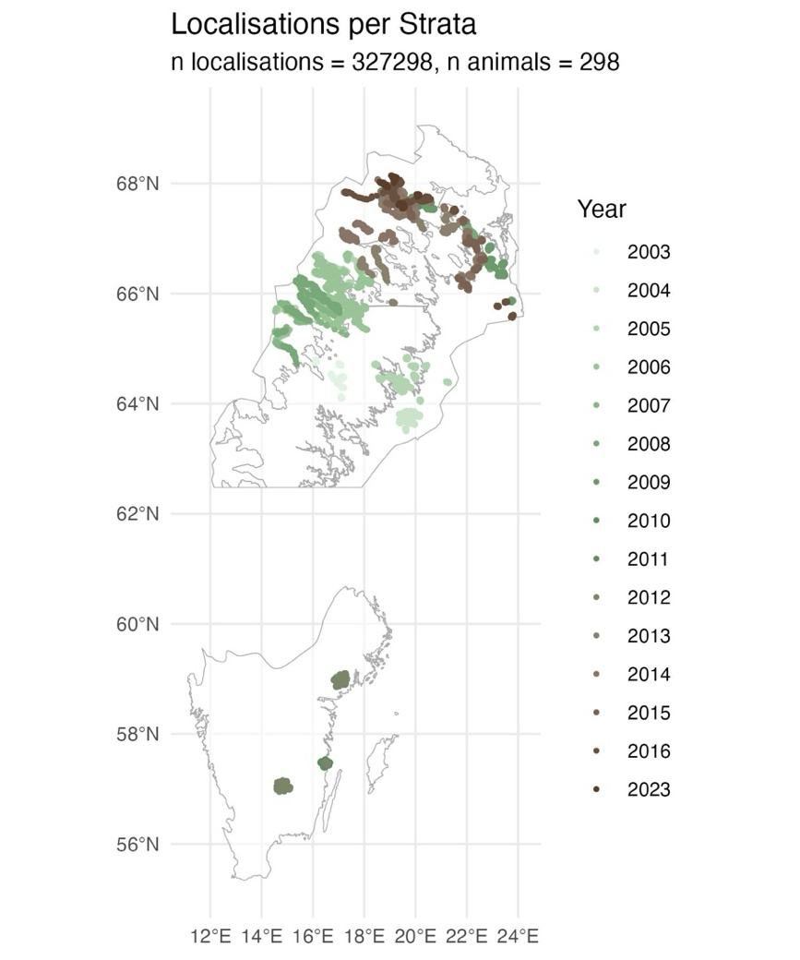
Random Step Generation
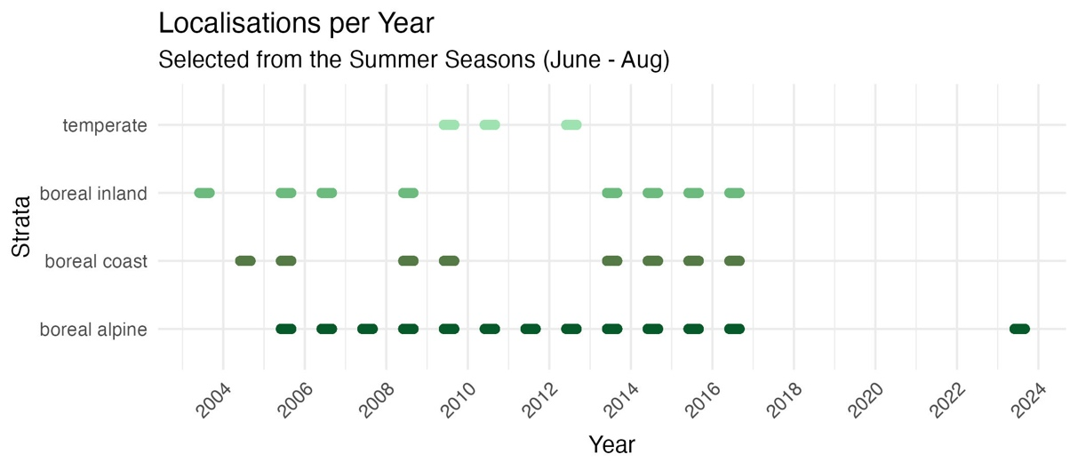
For each observed step, 15 random steps were generated using the amt package in R (Signer et al. 2019). Step lengths were modeled using a gamma distribution, and turning angles were modeled using a von Mises distribution, both standard choices for animal movement modeling (Avgar et al. 2016). Distributions were first fitted separately for each stratum, thereby estimating step-length and turning-angle distributions at the population level, with each stratum treated as a distinct population. This approach was adopted because moose inhabiting the boreal strata exhibit different morphology and movement behaviors compared to those in the temperate stratum, as reflected in their respective fitted step-length distributions. Fitting movement distributions at the population rather than the individual level facilitated the adjustment of the selection-free movement kernel to the actual movement kernel, resulting in gamma and von Mises distribution parameters specific to each stratum (Forrest et al. 2025).
Figure 1
Figure 2

Sampling Geographical Covariates
Each localization was annotated with a set of geographical covariates hypothesized to influence moose movement behavior during heatwaves. Covariates were selected either because they represented potential points of attraction, such as dense forests and clear-cut areas providing favorable foraging conditions, or potential points of repulsion, such as rugged terrain. An overview of the covariates included in the analysis is provided in Table 1.

Land use data were obtained from the Swedish Environmental Protection Agency's National Land Cover Database. Two datasets were used: one from 2003 with a spatial resolution of 25 m × 25 m, and one from 2018 onward with a spatial resolution of 10 m × 10 m. Land use categories were simplified into eight classes: coniferous forest, deciduous and mixed forest, clear-cut and young forest, low-mountain forest, wetlands, open areas, water bodies, and anthropogenic land. Because the land use data represented snapshots in time, forestry changes that occurred after the publication dates of these datasets would not be captured, despite the importance of clear-cuts as foraging habitats for moose. To address this, forest felling data from the Swedish Forest Agency were incorporated to manually update the land use maps. Localizations that occurred within ten years after a recorded felling event were reassigned to the "clear-cut and young forest" land use class. The average distribution of land use classes used by moose in each stratum between June and September is shown in Figure X. Based on these distributions, it was observed that moose predominantly utilized three to four specific habitat types per stratum. Therefore, for each stratum, only these commonly used habitat classes were retained for modeling, while the remaining classes were combined into a single "other" category. This step was necessary to meet the requirements of the two-stage SSF modeling approach, which assumes that each individual animal has visited each habitat class included in the model at least once.

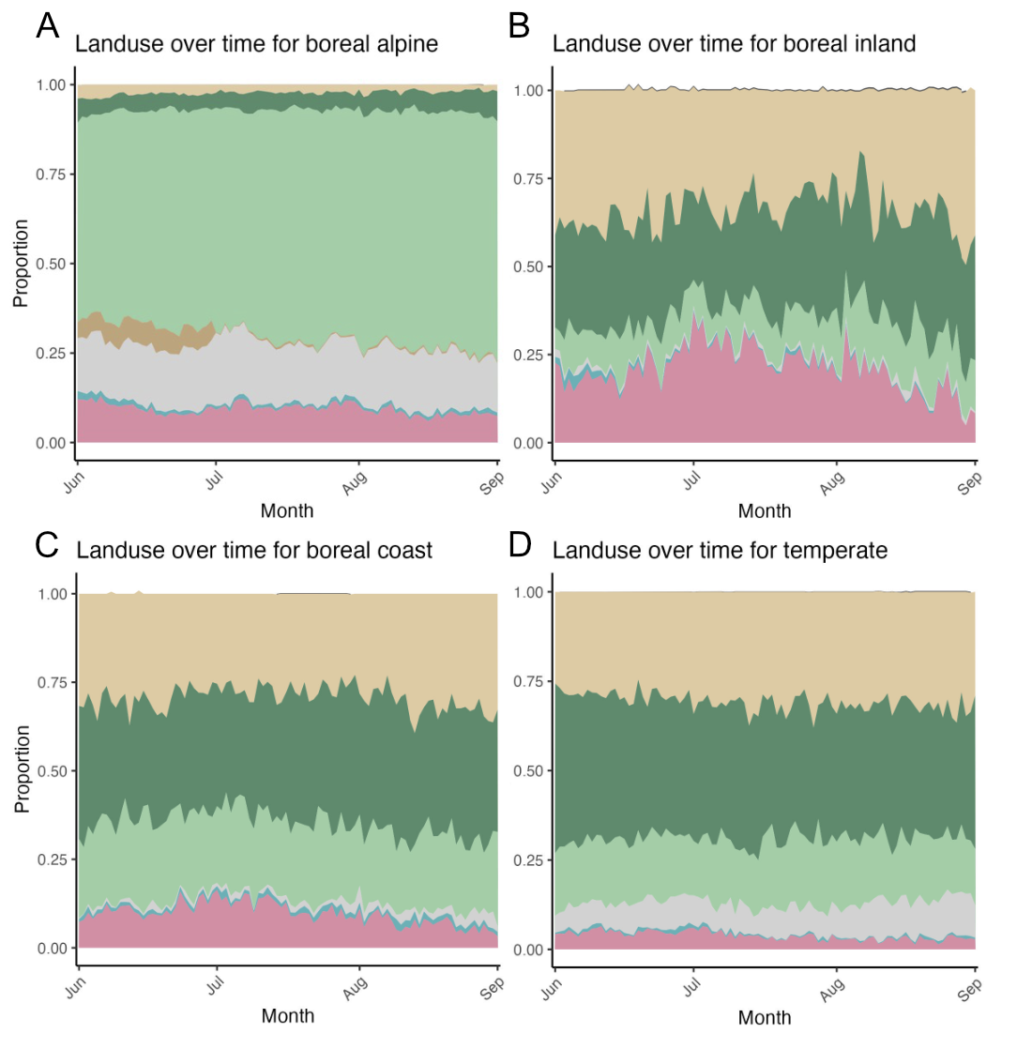
# TODO missing legend

In addition to land use, proximity to water sources was included as a covariate to investigate whether moose preferentially moved closer to water during heatwave conditions. A continuous raster layer of distances to the nearest water source was generated by applying the Proximity (Raster Distance) tool in QGIS to the water bodies layer derived from the land use map. Elevation was also included as an environmental covariate. Elevation data were obtained from Lantmäteriet (the Swedish mapping authority) at a spatial resolution of 50 m × 50 m. From these data, a terrain ruggedness index (TRI) was calculated following the method described by Riley et al. (1999) to quantify topographic heterogeneity, which could influence movement costs and habitat selection.

Name | Spatial Resolution | Year Origin | Source
Land use | 25m x 25m & 10m x 10m | 2003 & 2018 (continuously updated) | The Swedish Environmental Protection Agency, simplified into 7 classes.
Elevation | 50m x 50m | 2015 | Lantmäteriet
Terrain Ruggedness  Index (Riley et al., 1999) | 50m x 50m | 2015 | Derived from DEM (Lantmäteriet)
Distance to Water | 25m x 25 m | 2003 | Derived from land use (using proximity raster distance in QGIS).
Table 1: Geographical covariates used within the step selection analysis

Sampling Local Weather Through Space-Time Regression Kriging
To assess the effects of temperature extremes at fine spatial scales, several options for obtaining temperature data were considered: collar-derived sensors, the nearest weather station, and spatial interpolation methods. Collar-derived temperature data were ultimately rejected, as these sensors can produce outliers due to influences such as solar radiation, body heat, and wind exposure, limiting their interpretability for fine-scale environmental analysis. Although the use of the nearest weather station was also evaluated, this method was deemed inadequate for alpine and mountainous areas, where temperature varies strongly with elevation and local topography. As a result, space-time regression kriging was selected as the most suitable interpolation method. This approach allows for the incorporation of key predictors such as elevation, latitude, and day of the year, improving the representation of local temperature patterns over both space and time.

Data Collection and Regression Modeling
Weather data were obtained from the Swedish Meteorological and Hydrological Institute (SMHI) via their publicly available API. A Python package was developed to request and store weather data automatically in a PostgreSQL database (Appendix 2). Only weather stations with a "good" (G) quality rating, as indicated by the SMHI API, were included. Furthermore, to minimize spatial redundancy, stations located within 100 meters of another station were removed. Space-time regression kriging was implemented in R using the gstat and spacetime packages, following the methodology described by Sekulić et al. (2020). The first step involved fitting a regression model to the weather station data collected across all summer seasons within the study period. Explanatory variables included the year of measurement, a second-degree orthogonal polynomial of elevation, and the Geometric Temperature Trend (GTT), a variable that predicts daily mean temperature based on latitude and day of the year (Kilibarda et al. 2014). This regression model captured the broad spatial and temporal trends in temperature before kriging was applied to model the local residual variation.

Kriging Procedure
Following regression, space-time kriging was performed on the residuals to capture localized deviations from the large-scale temperature trend. Given the large volume of temperature observations, it was not computationally feasible to generate a single experimental semi-variogram for all available data. Space-time kriging is computationally intensive, with cubic time complexity, meaning that a tenfold increase in data points leads to a thousandfold increase in computation time (Yang et al. 2022). To balance computational feasibility with the need to capture short-term temperature variability, kriging was performed on a weekly basis. Weekly aggregation allowed the model to remain sensitive to short-term fluctuations, such as heatwaves, while ensuring that computational load remained manageable. Empirical and theoretical variograms were fitted separately for each week based on the residuals of the regression model. A small nugget effect was included to mitigate the screening effect, as some weather stations remained relatively close even after the filtering step (Stein 2002). Kriging was performed directly at the moose localization points rather than across a general prediction grid, targeting the specific locations of interest. Kriging computations were parallelized using the parabar package and conducted on a virtual machine hosted on DigitalOcean, with 48 CPU cores allocated. The full interpolation process required approximately 24 hours to complete. No unrealistic temperature artifacts were observed in the kriging outputs.

Model Validation
Model performance was evaluated using K-fold cross-validation. For each week, the weather station data were randomly divided into five folds, creating distinct training and validation sets. This procedure allowed the model to be tested across both spatial and temporal dimensions, offering a more thorough validation than methods based solely on spatial holdout, such as omitting entire stations. Although SMHI stations varied in their sampling frequency (with some recording hourly and others every three hours), the absence of significant temporal gaps in the data made K-fold cross-validation appropriate.

A summary of the regression model and kriging validation results is provided in the Results section, while full details are presented in Appendix 1.

Step Selection Functions
For each stratum, a Step Selection Function (SSF) model was created to investigate habitat selection by moose. Two separate models were fitted: one based on localizations that occurred during heatwaves and one based on localizations outside of heatwaves. Heatwaves were defined using biological extremes rather than climatological thresholds, as the precise onset of heat stress in moose remains debated [expand on this and provide the sources for the captive moose study]. Specifically, a heatwave was defined as a period of three or more consecutive days in which the daily maximum temperature exceeded the 80th percentile of the available moose temperature data within each stratum.

Model Covariates
Movement-related variables were included to account for the underlying movement process and to construct an integrated step selection function . These consisted of step length, its logarithm, and turning angle. Environmental variables were included at the end of each step and consisted of land use, distance to the nearest water body, and elevation. Each of the environmental covariates was given an interaction with the temperature at the end of the step to investigate how habitat selection varied as a function of thermal conditions. End-step temperatures were used instead of start-step temperatures because GPS localizations occurred at relatively coarse temporal intervals of approximately three hours. With such intervals, substantial environmental changes can occur along the step trajectory, making the end-point conditions a better approximation of the microenvironment ultimately selected by the animal. This ensured that modeled selection reflected actual conditions at the chosen location rather than at the beginning of the movement path.

In addition to temperature interactions, harmonic terms were included to account for cyclical daily patterns. Two pairs of sine and cosine terms were used to model time-of-day effects, one pair for the start of the step and one for the end. Following formula 2.2 with $j=1$ for one pair and $j=2$ for the second pair. These were interacted with both environmental and movement variables to allow selection to vary over the course of the day. Following Signer et al. (2019), the movement terms were interacted with harmonic terms calculated at the start of each step to investigate how the animals current conditions influence movement. In contrast, interactions for habitat-related variables used harmonic terms at the end of the step, as the aim was to assess habitat selection based on the conditions in the area to which the animal moved (i.e. selected for).

Tertiary interactions among environmental variables, time of day, and temperature were not included, as heatwave and non-heatwave conditions were already analyzed separately through distinct models. All variables were tested for collinearity using the Generalized Variance Inflation Factor (GVIF), adjusted for degrees of freedom, with GVIF being < 2 for all variables.

Model Fitting
Models were fitted using a two-step approach. First, an SSF was fitted separately for each individual moose, without random effects. Second, population-level inference was obtained by aggregating individual coefficients through an intercept-only linear regression (eq. x.x). Each coefficient was weighted by the inverse of its variance as per the two-stage procedure of fitting population level SSF (Fieberg et al. 2010; Muff et al. 2020)

$$\begin{aligned}fit=lm\left(coef∼1, weights=inv_var\right)\#\left(x.x\right)\end{aligned}$$

The SSF model formula used for individual-level fits is given in formula x.x.

$$\begin{aligned}\text{case}∼ \#\left(x.x\right)\end{aligned}$$
$$\underset{\text{Main habitat terms}}{\underbrace{\text{landuse}\text{_}\text{end}+\text{dist}\text{_}\text{to}\text{_}\text{water}\text{_}\text{end}+\text{elevation}\text{_}\text{end}}}+$$
$$\underset{\text{Terrain }\text{cost }\text{term}}{\underbrace{\text{ruggedness}\text{_}\text{end}}}+$$
$$\underset{\text{Movement terms}}{\underbrace{\text{sl}+\log\left(\text{sl}\right)+\cos\left(\text{ta}\right)}}+$$
$$\underset{\text{Habitat × time interactions}}{\underbrace{\begin{aligned}\left(\text{landuse}\text{_}\text{end}+\text{dist}\text{_}\text{to}\text{_}\text{water}\text{_}\text{end}+\text{elevation}\text{_}\text{end}\right): \\ \left(\text{hour}\text{_}\text{s1}\text{_}\text{t2}+\text{hour}\text{_}\text{c1}\text{_}\text{t2}+\text{hour}\text{_}\text{s2}\text{_}\text{t2}+\text{hour}\text{_}\text{c2}\text{_}\text{t2}\right)\end{aligned}}}+$$
$$\underset{\text{Movement × time interactions}}{\underbrace{\begin{aligned}\left(\text{sl}+\log\left(\text{sl}\right)+\cos\left(\text{ta}\right)\right): \\ \left(\text{hour}\text{_}\text{s1}\text{_}\text{t1}+\text{hour}\text{_}\text{c1}\text{_}\text{t1}+\text{hour}\text{_}\text{s2}\text{_}\text{t1}+\text{hour}\text{_}\text{c2}\text{_}\text{t1}\right)\end{aligned}}}+$$
$$\underset{\text{Stratified matched design}}{\underbrace{\text{strata}\left(\text{step}\text{_}\text{id}\right)}}$$
Equation x.x: Model used for integrated step selection analysis. Habitat selection and movement were modeled using main effects (e.g. land use, elevation), movement terms (step length, log-transformed step length, and cosine of turning angle), and interactions with time of day (harmonic terms). Harmonic terms were constructed using sine and cosine transformations of the time of day at both the start (*_t1) and end (*_t2) of each step. Terms of the form hour_s1_t2, hour_c2_t1, etc., represent sinusoidal transformations with 2 cycles per 24 hours, enabling the model to capture diel activity rhythms and their influence on both movement and habitat selection.

Results
Providing the results here roughly in the order of the hypothesis, describing in each subheading which hypotheses are investigated

Heatwave events

Movement during heatwave events

Landuse preference during heatwave events

Elevation and distance to water preference during heatwave events

Discussion and Conclusion
Three pairs of harmonics were initially tested but often resulted in model convergence issues due to some animals not visiting all habitat types at every harmonic timestamp. This led to missing interaction terms, making two pairs the most consistent and reliable option.

Limited temporal resolution, which has been shown to make it difficult to find significant results and fine scale behaviour.

Limitations in calculating bootstrapped confidence intervals due to errors and shifts in phase.

Limited spatial resolution, and limited quality of landcover maps. An attempt was made using what is available, but future work should focus on incorporating remote sensing derived indexes such as NDVI

Two step conditional regression has its limitations, in categorical variables it is mostly that every animal needs to have visited every categorical variable. A more robust way is to portray habitat through continuous variables.

Other implementions such as through GLMMT and mcsv are possible, and can be considered for small scale studies where the number of individuals is limited.

Consider daylight length by anchoring time

Further studies into boreal circadian rhythm and extreme weather required

References

Popular science summary
This is the style “Text after heading”. This is the style “Text after heading”. This is the style “Text after heading”. This is the style “Text after heading”. This is the style “Text after heading”. This is the style “Text after heading”.
This is the style “Normal”. This is the style “Normal”. This is the style “Normal”. This is the style “Normal”.

Appendix 1 – Sampling Temperature with Space-Time Regression Kriging

SMHI Mock Database
To efficiently handle large volumes of weather data, I implemented a database layer between the client and the SMHI API. This layer minimizes redundant API requests and allows for faster querying during analysis. The backend is powered by PostgreSQL 16, extended with PostGIS to manage spatial vector data. PostgreSQL was chosen for its performance, scalability, and strong support for spatial operations. Data ingestion and querying were handled using Python. I used the requests library to communicate with the SMHI API, and SQLAlchemy to interface with the PostgreSQL database. This setup allowed me to seed the database with all available SMHI stations once, thereby eliminating the need for repeated API calls during subsequent analyses. Most weather stations in the database recorded temperature either hourly or every three hours. Three-hour intervals were more common in the earlier years of the study period, whereas hourly recordings became more frequent in later years.

Linear Regression Model
As the first step in the kriging workflow, I fitted a linear regression model using all available summer weather data from the study period (2004–2023). This model served to extract residuals that could be interpolated using kriging. The explanatory variables included elevation, the year of measurement, and Growing Temperature Threshold (GTT), which was calculated using the r-meteo package based on latitude and day of the year. The model accounted for 26.4 percent of the variation in temperature across the temporal window of interest. To assess whether a linear relationship was appropriate, I inspected a Q-Q plot of the residuals. The plot showed approximate normality, with only minor deviations at the higher end of the distribution. This indicated that the model's assumptions were reasonably satisfied. The coefficients of the regression model are shown in Table 1. Elevation had a small but consistent negative effect on temperature, while GTT showed a strong positive relationship. Yearly effects were significant across the entire range, except for the year 2022.

Variable name | B Estimate | Std.Error | P-value
(Intercept) | 6.717 | 1.627e-02 | <2e-16 ***
elevation | -5.533e-03 | 8.039e-06 | <2e-16 ***
gtt | 7.387e-01 | 8.507e-04 | <2e-16 ***
Year 2004 till Year 2023 | (,) | (,) | All <2e-16 ***  except 2022 (0.593)

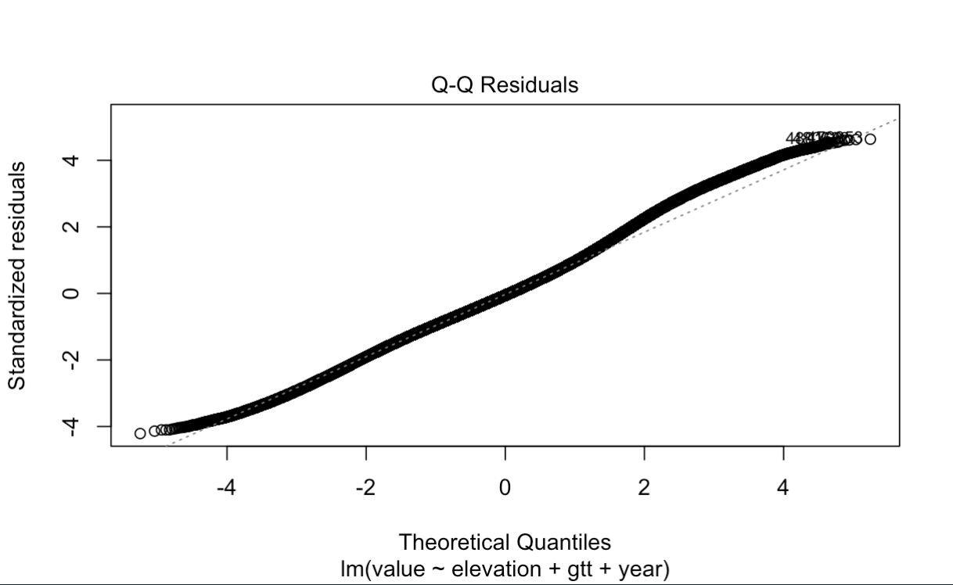

Semi-variogram Fitting
To address the computational demands of kriging, which has cubic time complexity, I divided the dataset into weekly intervals. This allowed me to run separate variogram models on each week, reducing memory and processing requirements. Across the different summer weeks I examined, I did not observe major differences in the fitted variograms. While this conclusion is based on visual inspection rather than formal testing, the same parameter values appeared to fit reasonably well throughout the summer period. This suggests that, although the underlying process may not be strictly stationary, the variogram model and parameters were consistently applicable to the data used. For illustration, I present the results for the week of 1 June to 7 June 2018. An empirical variogram was fitted using the spacetime package in R. I used this variogram to derive initial parameters for the model variogram (see Table 2). A small nugget effect was included for both the spatial and temporal dimensions. This decision was made to counteract the screening effect caused by the close proximity of some weather stations, which occasionally led to negative kriging weights. I then fitted a model variogram based on these initial values. The results of this fitted model are presented in Table 3.

 | Partial-sill | Range | Nugget
Space | 6 | 550000 | 0.001
Time | 30 | 10 | 0
Joint | 4 | 50000 | 0.001

 | Partial-sill | Range | Nugget
Space | 6.4286891 | 550000 | 0.3684194
Time | 299.3258 | 193.5573 | 0
Joint | 0.001 | 50000 | 0.001

I should be noted I did not perform a full sensitivity analysis to optimize starting values or parameter bounds. Instead, I selected a model that consistently converged and provided a good empirical fit. The sum-metric variogram model proved to be the most stable across different weeks and appeared well-suited to summer temperature data. For those planning to apply this methodology in other contexts, it is worth noting that I encountered more difficulty fitting variogram models to winter temperature data. In these cases, adjustments to the initial parameter values were often required to obtain a reasonable fit. While this was not central to my study, it may be an important consideration for future applications.

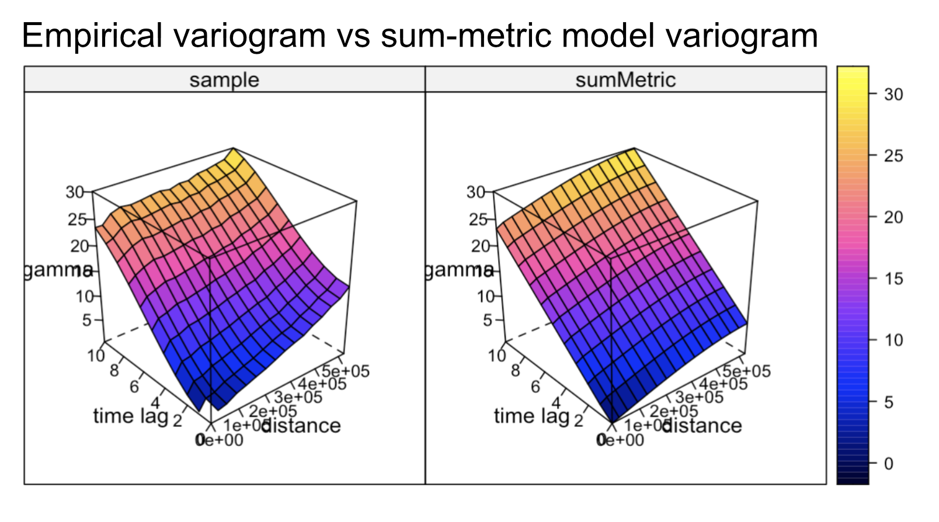

Cross Validation
To evaluate the accuracy of the space-time regression kriging model, I conducted a five-fold cross-validation. This involved dividing the weather dataset into five parts, training the model on four parts, and testing on the remaining one, cycling through all combinations. The model consistently explained approximately 96 percent of the variance in the held-out data across all folds. Mean absolute error was 0.96, and root mean square error was 1.36. These low error values indicate that the model has sufficient precision for the purposes of this study, where small deviations of a 1 or 2 degrees Celsius are unlikely to influence the overall results meaningfully.

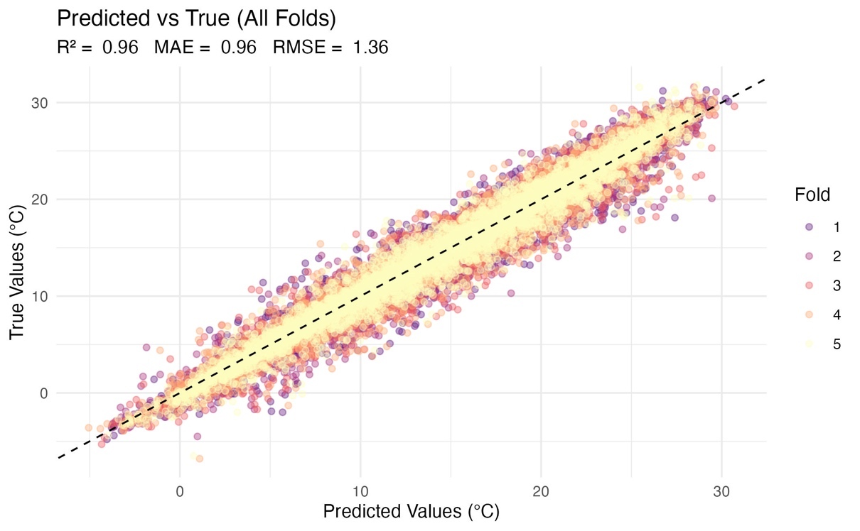

Predicitng Temperature at Moose Localisations
To estimate temperature at the locations of moose and random steps, I split the data into weekly batches. For each batch, I retrieved the corresponding week of weather data from the database, applied the linear regression model, fitted the variogram (using the same initial values as above), and then performed kriging. This was done independently for each batch, using the residuals from the regression as input for kriging. The entire process was parallelised using the parabar package.

Hardware Details
Parallellisation significantly reduced runtime for the most computationally expensive parts of the workflow. Annotating temperature at moose localisations using space-time regression kriging required approximately 20 hours using 48 CPU cores. This step was one of the most resource-intensive components of the entire analysis.

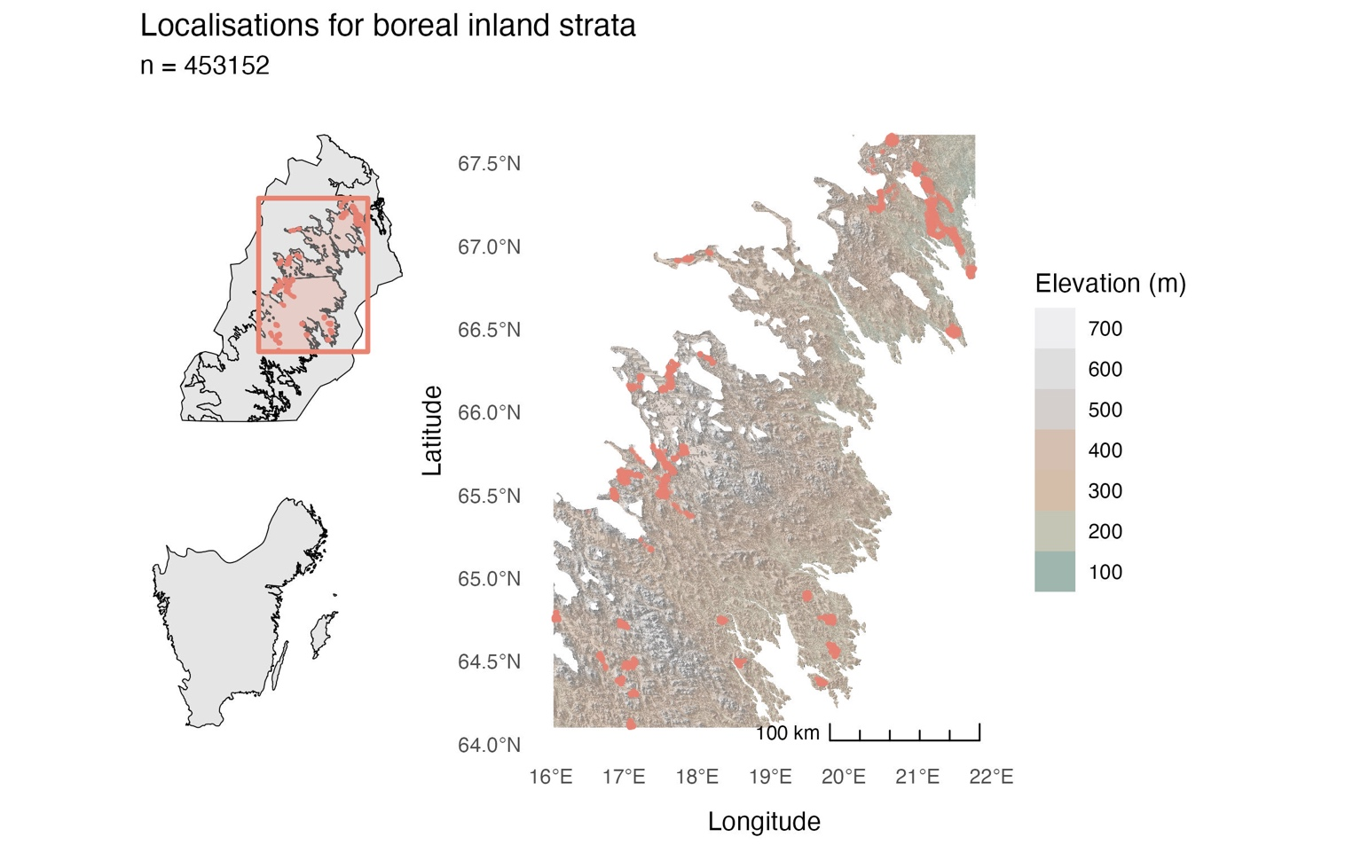
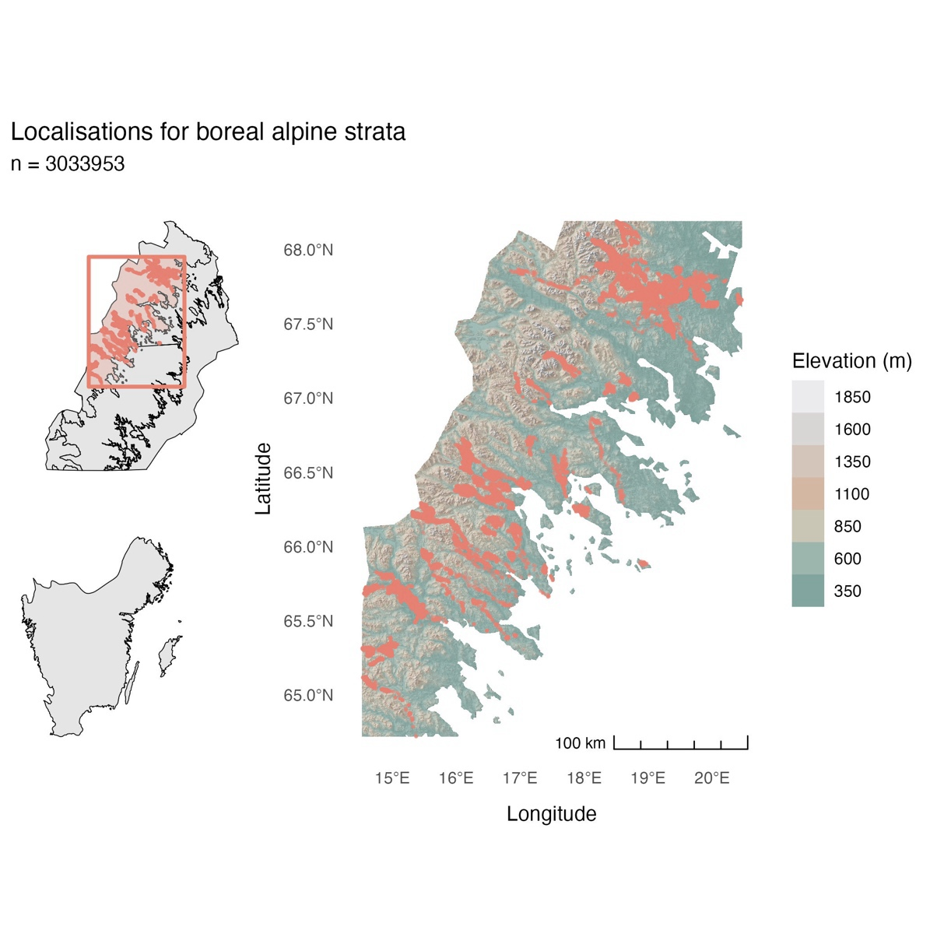
Appendix 2 – Moose Localisation Maps
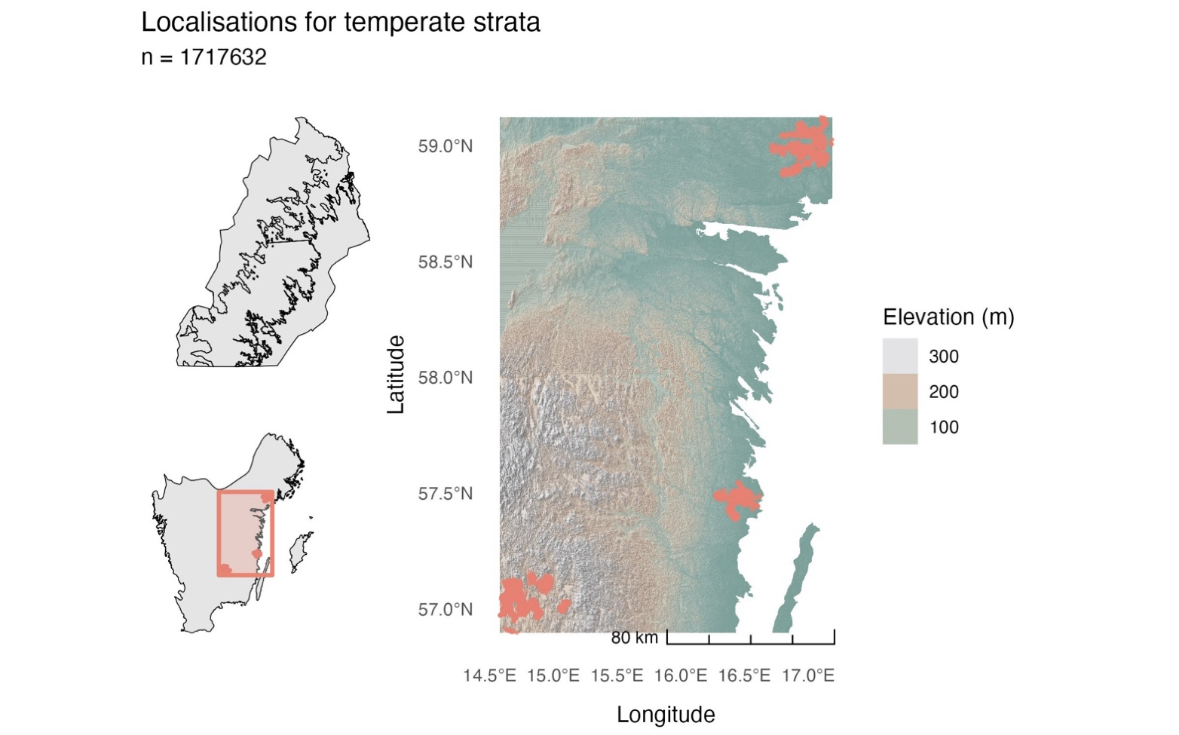
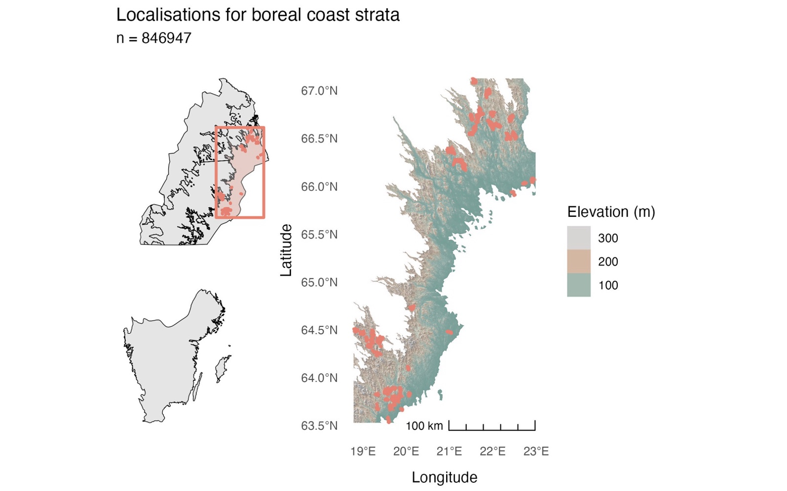

Appendix 3 – Code Availability
Quarto notebooks including explanations of the methodology and reproduction steps can be found at: (Fieberg et al. 2010). View the README.md for help setting up the environment. All spatial data used foranalysis was kept in the coordinate reference system SWEREF-99 (EPSG:3006).

Publishing and archiving
☒ YES, I, Niels van der Vegt, have read and agree to the agreement for publication and the personal data processing that takes place in connection with this

